Project Name
Waffarha

Project Idea
A 2D motion graphics promotional video for the 'Waffarha' application. The video addresses the daily struggle of traditional shopping, such as time consumption and physical effort. It presents 'Waffarha' as the ultimate solution that offers home delivery, safety, order tracking, and continuous discounts, encouraging users to download the app."

Team Members
Mariam Samy
Heba Mohammed
A'laa Hesham
Veronia Reda
Andrew Ayman
Ali Sameh

Work Plan
- Research & Analysis
  - Audience personas: Targeted busy demographics including employees, students, and housewives (Aged 18-45) who value convenience and savings.
- Visual Identity
  - Logo design: Animated the official Waffarha logo to create a dynamic intro and outro for the promotional video.
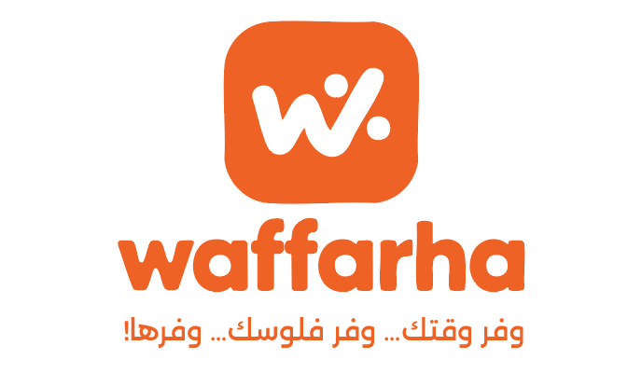
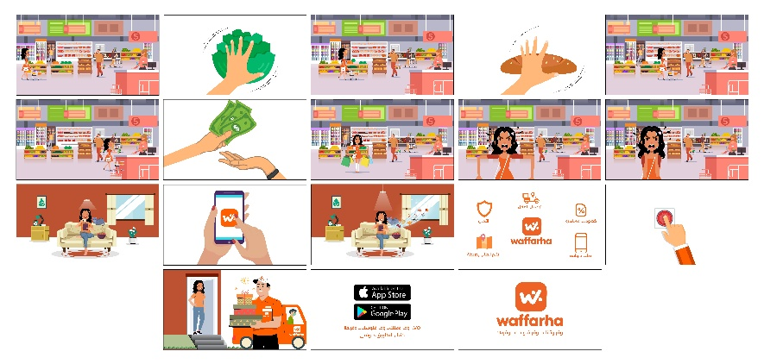
- Main Designs: Designed custom vector characters (The Shopper, The Delivery Man) and detailed backgrounds (Supermarket, Living Room) using Adobe Illustrator.

- Review & Finalization: The team reviewed the animation timing, ensuring the voiceover synchronized perfectly with the visual elements and sound effects.
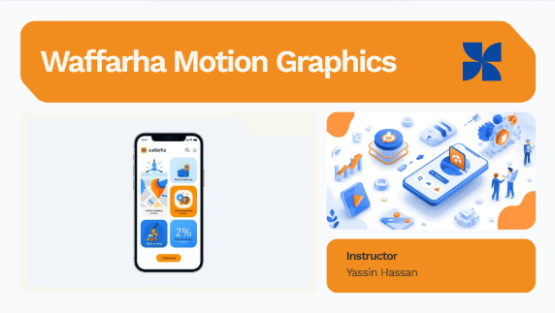
- Final Presentation: Prepared a comprehensive presentation covering the project lifecycle, from problem statement to the final video showcase.

Roles & Responsibilities
- Mariam Samy:
- Motion Graphics Animator: Responsible for animating the second half of the video (Timecode: 00:24 – End).
- Video Editor & Compositor: Merged the two animation parts and handled the final video rendering.
- Sound Engineer: Managed full audio mixing and synchronization.
- Andrew Ayman:
- Motion Graphics Animator: Responsible for animating the first half of the video (Timecode: 00:00 – 00:24).
- Visual Designer: Designed vector icons and animated the Waffarha logo (Intro/Outro).
- Heba Mohammed:
- Storyboard Artist: Created the complete storyboard sketches to visualize the script before animation.
- A'laa Hesham:
- Voiceover Artist: Recorded the official voiceover for the video.
- Sound Researcher: Sourced sound effects and background music.
- Presentation Designer: Designed and prepared the final project presentation.

- KPIs (Key Performance Indicators)
  - Video Duration: 01:05 minutes (Delivered on time).
  - Visual Quality: High-quality 1080p rendering with smooth character animation.
  - Message Clarity: The video clearly communicates the app's value proposition (Saving time & money).
  - Viewer Engagement: Attractive visuals and sound effects designed to maximize viewer retention.

Instructor:
Yassin Hassan

Project Files
You can find the full project files here:
Waffarha

License
This project is licensed under the MIT License.

